DAY 10: MORNING ASSESSMENT

Q1) create a table with columns and rows

column name : students,technology,marks

add the column teacher

and delete the technology later

and try to to practice on all the example methods

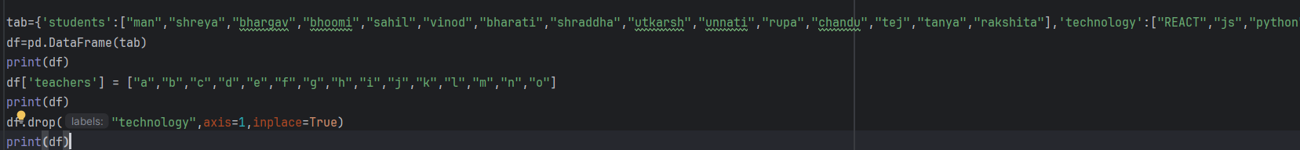

tab={'students':["man","shreya","bhargav","bhoomi","sahil","vinod","bharati","shraddha","utkarsh","unnati","rupa","chandu","tej","tanya","rakshita"],'technology':["REACT","js","python","java","c++","c#",".net","docker","devops","web tech","app dev","machinelearnif","aiml","backend","nodejs"],'marks':[12,13,14,15,16,27,18,19,20,30,40,50,55,60,70]}

df=pd.DataFrame(tab)  
print(df)

df['teachers'] = ["a","b","c","d","e","f","g","h","i","j","k","l","m","n","o"]  
print(df)

df.drop("technology",axis=1,inplace=True)  
print(df)

1. Read a CSV file into a Pandas DataFrame . Load data.csv and display the first 5 rows.

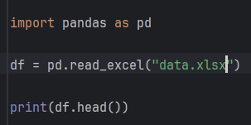

Output:  
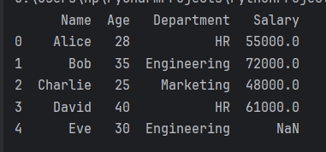

2. Check the shape of a DataFrame . How many rows and columns are present?

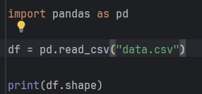

Output: (10, 4)

3. Get summary statistics

Use a method to get min, max, mean, etc., for numeric columns. Data Selection and Filtering

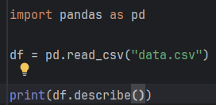

Output:

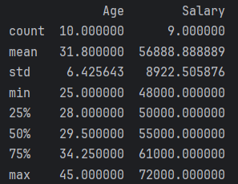

4. Select a single column. Extract the "Age" column as a Series.

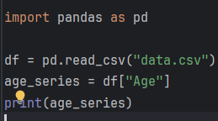

5. Filter rows based on condition. Show rows where "Salary" > 50000.

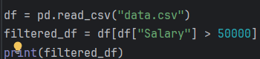

Output:

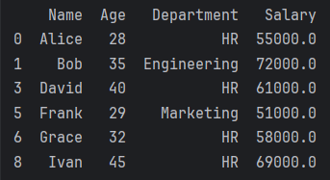

6. Filter multiple conditions.

Display rows where "Department" == 'HR' and "Age" > 30. Data Cleaning

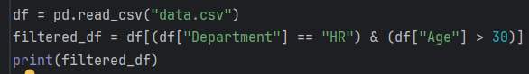

Output:

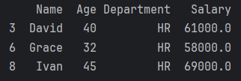

7. Check for missing values .Find which columns have NaN values and how many.

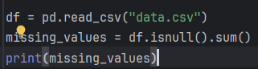

Output: 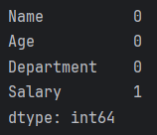

8. Replace missing values . Fill NaN values in "Salary" with 0.

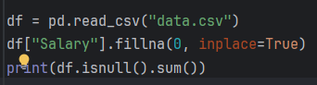

Output: 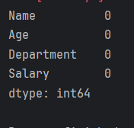

9. Remove duplicate rows .Drop duplicates and reset the index. Data Aggregation and Sorting

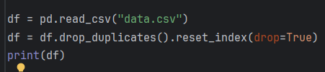

10. Sort the DataFrame by a column .Sort rows by "Age" in descending order.

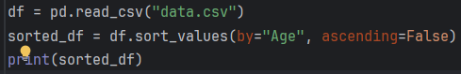

Output:

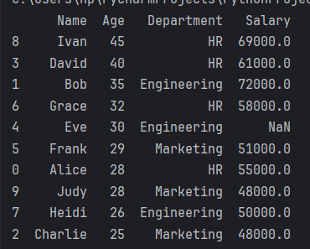

11. Group by and aggregate .Group by "Department" and find the average "Salary".

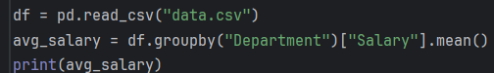

Output:  
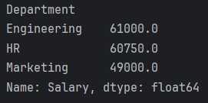

12. Count unique values . How many unique departments are there in the "Department" column?

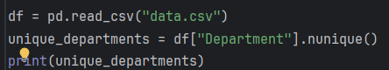

Output: 3